MINI PROJECT USING C
TEAM MEMBERS
- Aditya Modi-1262251147
- Mandar Ghule-1262253047
- Utkarsh Pagar-1262253678
- Omkar Hirave-1262254103
- Aditya Sale-1262253092

PROJECT GUIDE
Dr. Renuka Mane
(FOP Program Co-Ordinator)

INSTITUTION
Dr. Vishwanath Karad
MIT WORLD PEACE UNIVERSITY

SUBMISSION DATE
ACKNOWLEDGMENT
We want to say thank you to our faculty member for helping us much with this project. She gave us good advice and supported us all the way. We also liked her idea to look at simulations on the PhET website. This helped us understand things better and think of ideas when we were making our own Physics Lab Simulator in C.
We really appreciate that she told us to do something different and not just copy what is already out there. This made us want to add things to our project. For instance when we were working on the projectile motion experiment we added some pictures to help show what was happening like how kinetic energy and potential energy work together. We did this with experiments too.
We also want to thank our friends and the people we worked with on this project. They were really helpful. We shared ideas together. This was a part of why we were able to finish the project.
We are thankful to everyone who helped us with this project no matter how they helped us.

ABSTRACT

This project is about a Physics Lab Simulator that we made using C and the WinBGIm graphics library. The Physics Lab Simulator is a tool that helps people see physics in a digital way. We made the Physics Lab Simulator because we wanted to connect what we learn in class to what we can actually see and do. The Physics Lab Simulator is really good, for understanding physical phenomena in a fun and interactive way.

OBJECTIVE
The main goal was to create an educational tool that works in real-time.This tool lets users change things like focal length, wave frequency and projectile velocity.They can then see what happens away on a graph.The tool is modular which means it is made of parts that can be easily changed or added to.Users can play with variables and see the results immediately.This helps them learn by experimenting with length, wave frequency and projectile velocity in a hands-on way.
METHODS
The simulator utilizes procedural programming and coordinate geometry to render five distinct modules:
- Ray Optics: Simulating image formation in convex and concave lenses.
- Interference: Demonstrating Young’s Double Slit experiment with dynamic fringe patterns.
- Wave Superposition: Visualizing the constructive and destructive interference of two independent waves.
- Projectile Motion: Tracking trajectories on normal and inclined planes.
- 3D Polarization: Illustrating linear, circular, and elliptical wave propagation.
TABLE OF CONTENTS

MINI PROJECT USING C 1
TEAM MEMBERS 1
PROJECT GUIDE 1
INSTITUTION 1
SUBMISSION DATE 1
ACKNOWLEDGMENT 2
ABSTRACT 3
OBJECTIVE 3
METHODS 3

9. Implementation
The implementation of the Physics lab simulator was carried out using C programming language along with graphics libraries to provide visuals for experiments. The project was designed in a modular way, where each physics concept was implemented as an independent simulation module.

9.1 Development Environment
The project was developed using the following tools and technologies:
- Programming Language: C
- Graphics Library: graphics.h
- Additional Libraries: math.h, windows.h, conio.h, stdio.h
- Platform: Windows
- Compiler/IDE: Code::Blocks
Main component of program was graphics.h, it simulated all physics experiments using formulas and algorithms.

9.2 System Implementation Details
The system is structured as a menu-driven application, where the user can select different physics experiments. Each experiment is implemented as a separate module (each module of code is created by each group member), ensuring modularity and easy maintenance.
Main Menu Module:
The main function displays a console-based menu:
- Ray Optics
- Double Slit Interference
- Wave Superposition
- Projectile Motion
- Polarisation Wave
Based on user input, the corresponding simulation function is executed.

Module 1: Ray Optics Simulation
This module simulates image formation using convex and concave lenses.
- Calculates image distance using the lens formula
- Displays object and image positions graphically
- Allows user interaction through keyboard:
  - Adjust focal length and object distance
  - Switch between convex and concave lens
  - Graph mode for parameter visualization

Module 2: Double Slit Interference
This module demonstrates interference patterns formed by two coherent light sources.
- Uses intensity formula based on cosine square variation
- Displays fringe patterns on a screen
- Parameters such as wavelength, slit distance, and screen distance can be adjusted in real time

Module 3: Wave Superposition
This module visualizes the superposition of two waves.
- Displays individual waves and resultant wave
- Allows control over:
  - Amplitude
  - Wavelength
  - Phase difference
- Includes a graph panel for parameter analysis

Module 4: Projectile Motion
This module simulates projectile motion under gravity.
- Supports motion on flat ground and inclined plane
- Displays trajectory dynamically
- Graph mode allows plotting relationships like:
  - Time vs Height
  - Velocity vs Time
  - Energy variations

Module 5: Polarisation Wave
This module demonstrates 3D polarization of light waves.
- Shows linear, circular, and elliptical polarization
- Uses projection techniques to simulate 3D visualization
- Allows adjustment of amplitude, phase, and frequency

9.3 Code Snippets + Output
The following snippet represents the core physics calculation used in the all modules:
1]Ray Optics:
Formula snippit:
float v = (u*F)/(u+F);
float m = v/u;
float h = 60*m;

Output:
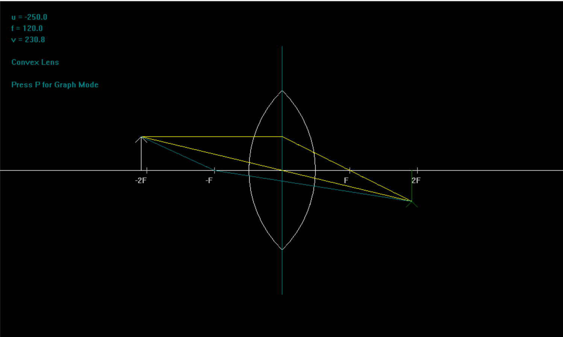
This formula is used to calculate image distance and magnification based on object distance and focal length.

9.4 Testing
Testing was performed to verify correctness, stability, and user interaction.
Types of Testing Conducted:
- Functional Testing: Verified each simulation module individually
- Interactive Testing: Checked real time response to keyboard inputs
- Graph Validation: Ensured graphs reflect correct physical relationships
Sample Test Cases:
Test Case | Input | Expected Output | Result
Lens Simulation | u = -250, f = 120 | Correct image position | Passed
Interference | Increase wavelength | Fringe spacing increases | Passed
Superposition | Phase shift applied | Wave pattern changes | Passed
Projectile | Angle = 45° | Parabolic trajectory | Passed
Polarisation | Circular mode | Circular wave pattern | Passed
The system responded accurately under all tested conditions.

10. Results and Discussion
10.1 Output
The simulator successfully demonstrated multiple physics concepts in an interactive and visual manner. Each module produced outputs consistent with theoretical expectations.
The real-time adjustments allowed better understanding of how different parameters affect physical behavior.

10.3 Analysis
The results obtained from the simulator closely matched theoretical predictions:
- Ray optics simulation correctly followed lens formulas
- Interference patterns varied as expected with wavelength and slit distance
- Wave superposition clearly demonstrated constructive and destructive interference
- Projectile motion followed a parabolic trajectory consistent with physics laws
- Polarisation modes visually represented different wave behaviors
One of the major strengths of the system is its interactive nature, which allows users to experiment and observe changes in real time.
However, some limitations were observed:
- Graphics are dependent on older libraries
- Limited resolution and rendering capabilities
- Runs only on specific environments
Despite these limitations, the system effectively achieves its educational purpose.

11. Conclusion
The Physics Lab Simulator was successfully developed to provide a virtual platform for understanding key physics concepts. The project integrates multiple experiments into a single application, making it both efficient and user-friendly.
Through this project, practical implementation of theoretical concepts such as optics, wave behavior, and motion was achieved. The use of graphical visualization significantly enhances comprehension compared to traditional methods.
Overall, the objectives of the project were met, and the simulator serves as a useful educational tool for students.

12. Future Scope
Although the current system performs well, there are several opportunities for improvement and expansion:
- Modern Graphics Integration:
Replace graphics.h with OpenGL, SDL, or a modern GUI framework for better visuals
- Cross-Platform Support:
Make the application compatible with Linux and macOS
- Improved User Interface:
Add buttons, sliders, and mouse interaction instead of keyboard-only controls
- Additional Experiments:
  - Electric fields
  - Magnetic fields
  - Thermodynamics simulations
- Web-Based Version:
Convert the simulator into a web application for easier accessibility
- 3D Enhancements:
Improve 3D visualization for better realism
- Educational Features:
Add theory explanations, quizzes, and guided experiments
These improvements can make the simulator more powerful, accessible, and suitable for real-world educational use.
13. Research Paper / Patent Details
1.Abstract:
The project undertakes an interactive physics simulation system designed in the C programming language. The system aids in the visualization of physics concepts such as ray optics, wave interference, projectile motion, and polarization.

2. Objective
To create a virtual physics lab
To visualize complex physics concepts
To make learning an interactive experience
3. Methodology

The system consists of five modules:

Ray Optics
Young’s Double Slit
Projectile Motion
Wave Superposition
Wave Polarization

Each module includes real-time simulation with user input.

4. Technology Used
C Programming
graphics.h Library
Real-time keyboard input
Double buffering for smooth display
5. Key FeaturesInteractive simulations
Real-time parameter change
Conduct multiple experiments in one system
6. Innovation / Patent Idea
Combines multiple physics simulations in one system
Low-cost virtual physics lab
Suitable for incorporating advanced UI or AI for patent purposes
7. Conclusion
The project undertakes an efficient system for creating a virtual physics lab.

14. References

Books
1.Halliday, D., Resnick, R., & Walker, J.
Fundamentals of Physics, Wiley Publication.
2.H.C. Verma
Concepts of Physics (Vol. 1 & 2)
3.Serway, R.A., & Jewett, J.W.
Physics for Scientists and Engineers
15. Plagiarism Check
